**A**

**PROJECT REPORT**

**ON**

**“TWITTER DATA ANALYSIS”**

**SUBMITTED BY**

**DHIRAJ K. SHELKE PRANAV N. GAVALI KOMAL P. NAPHADE**

**(COBB071) (COBB046) (COBB018)**

**GUIDED BY:**

**PROF. M. E. SANAP**

**HOD:**

**PROF. A. N. ADAPANAWAR**

**PRINCIPAL:**

**PROF. K. P. PATIL**

**DEPARTMENT OF COMPUTER ENGINEERING**

**STES’S SINHGAD ACADEMY OF ENGINEERING KONDHWA (BK), PUNE**

**2021-2022**

**Software Requirements:** Rapid Miner

**Hardware Requirement:** PIV, 2GB RAM, 500 GB HDD, Lenovo A13-4089Model.

**Theory:**

“Twitter Sentiment Analysis”, also referred to as opinion mining, is an approach to natural language processing (NLP) that identifies the emotional tone behind a body of text. This is a popular way for organizations to determine and categorize opinions about a product, service, or idea. It involves the use of data mining, machine learning (ML) and artificial intelligence (AI) to mine text for sentiment and subjective information. Sentiment analysis systems help organizations gather insights from unorganized and unstructured text that comes from online sources such as emails, blog posts, support tickets, web chats, social media channels, forums and comments. Algorithms replace manual data processing by implementing rule-based, automatic or hybrid methods. Rule-based systems perform sentiment analysis based on predefined, lexiconbased rules while automatic systems learn from data with machine learning techniques. A hybrid sentiment analysis combines both approaches. In addition to identifying sentiment, opinion mining can extract the polarity (or the amount of positivity and negativity), subject and opinion holder within the text. Furthermore, sentiment analysis can be applied to varying scopes such as document, paragraph, sentence and sub-sentence levels. Vendors that offer sentiment analysis platforms or SaaS products include Brandwatch, Hootsuite, Lexalytics, NetBase, Sprout Social, Sysomos and Zoho. Businesses that use these tools can review customer feedback more regularly and proactively respond to changes of opinion within the market.

**Types of sentiment analysis:**

1. Fine-grained sentiment analysis provides a more precise level of polarity by breaking it down into further categories, usually very positive to very negative. This can be considered the opinion equivalent of ratings on a 5-star scale.
2. Emotion detection identifies specific emotions rather than positivity and negativity. Examples could include happiness, frustration, shock, anger and sadness.
3. Intent-based analysis recognizes actions behind a text in addition to opinion. For example, an online comment expressing frustration about changing a battery could prompt customer service to reach out to resolve that specific issue.
4. Aspect-based analysis gathers the specific component being positively or negatively mentioned. For example, a customer might leave a review on a product saying the battery life was too short. Then, the system will return that the negative sentiment is not about the product as a whole, but about the battery life.

**Applications of sentiment analysis:**

Sentiment analysis tools can be used by organizations for a variety of applications, including: 1) Identifying brand awareness, reputation and popularity at a specific moment or over time. 2) Tracking consumer reception of new products or features. 3) Evaluating the success of a marketing campaign. 4) Pinpointing the target audience or demographics. 4) Collecting customer feedback from social media, websites or online forms. 5) Conducting market research. 6) Categorizing customer service request.

**Project view:**

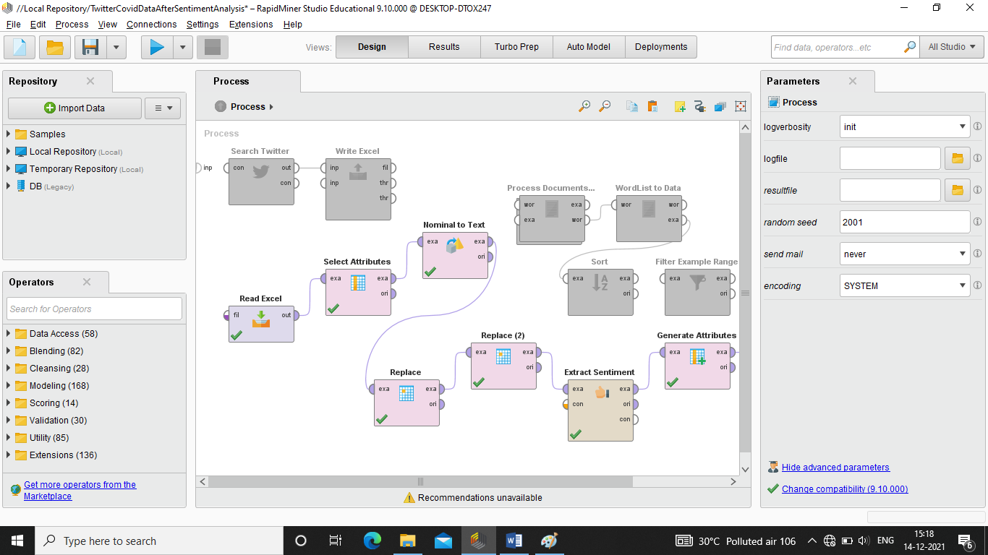

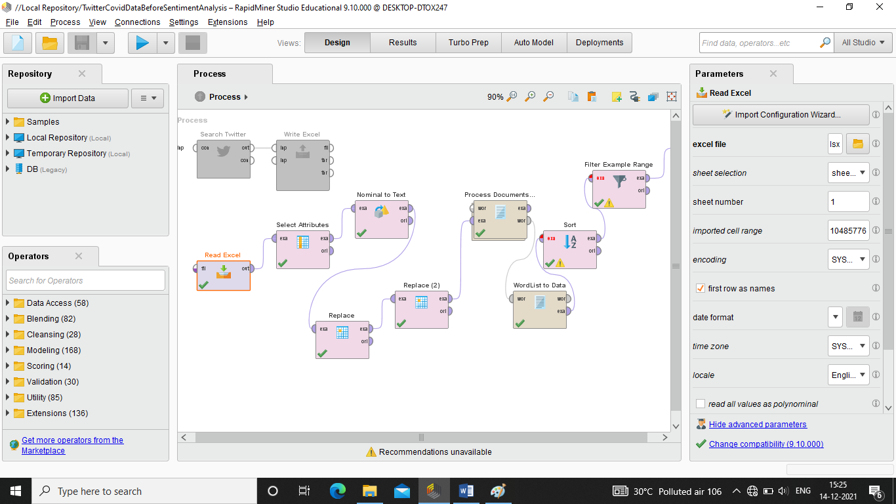

**Project Output:-**

1. **Dataset Output**

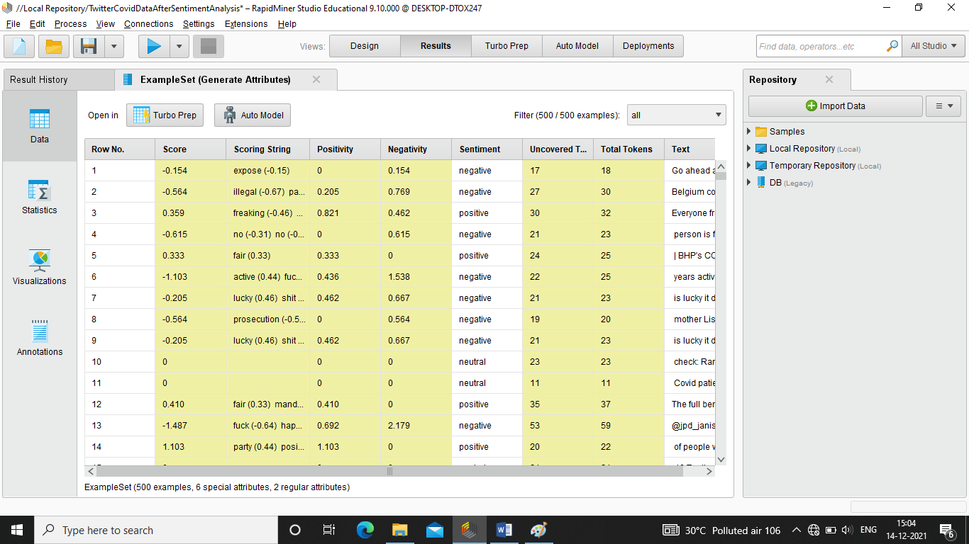

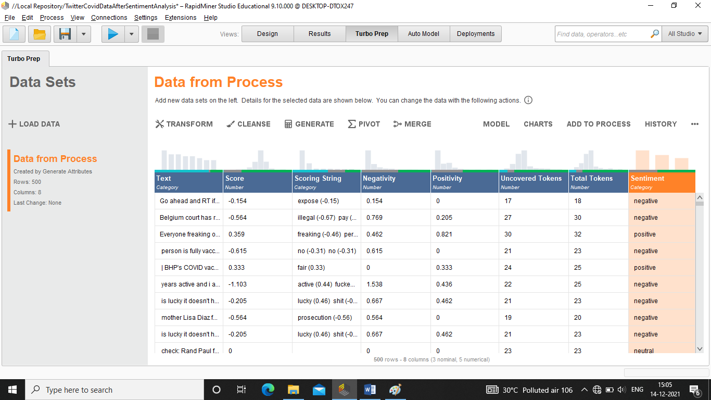

1. **Bar Chart: On Sentiment**

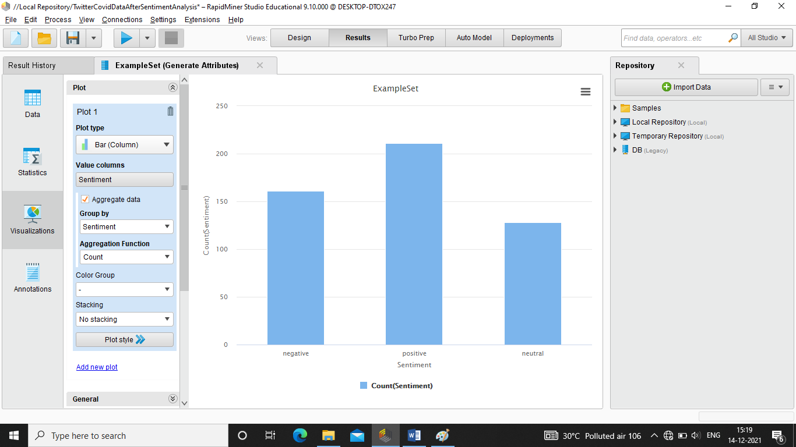

1. **Word Cloud: On Most Mentioned Words**

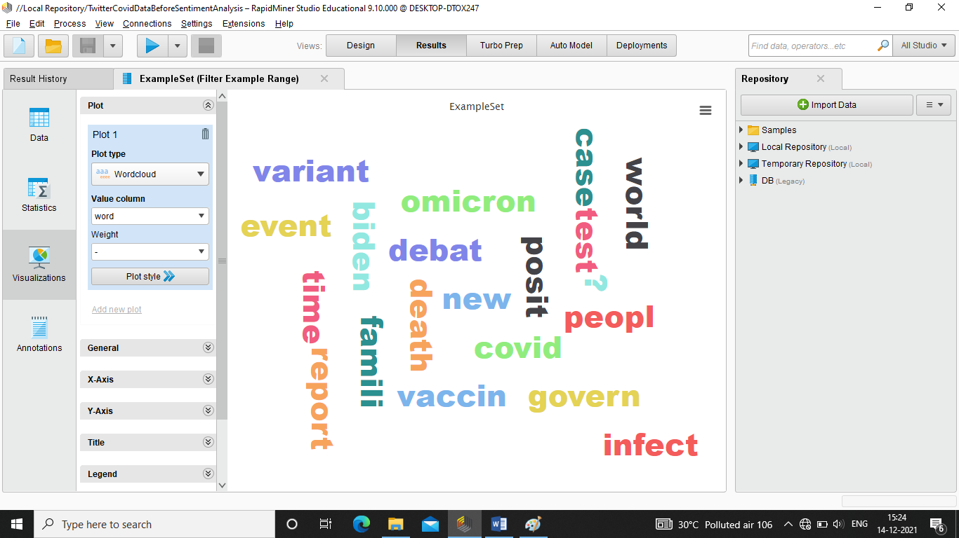

1. **Statistical Views of Generated Attributes**

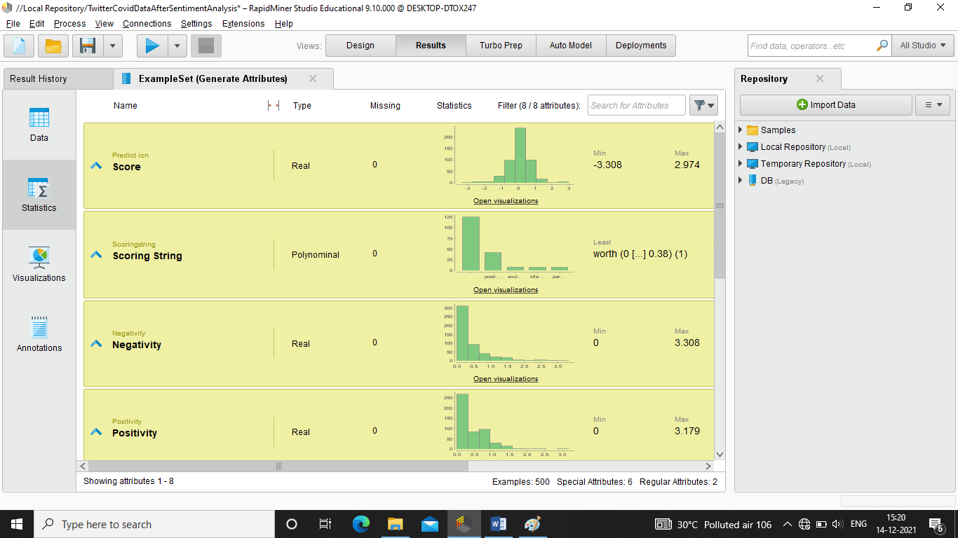

1. **Automatic Model Generation: Naive Bays Model**

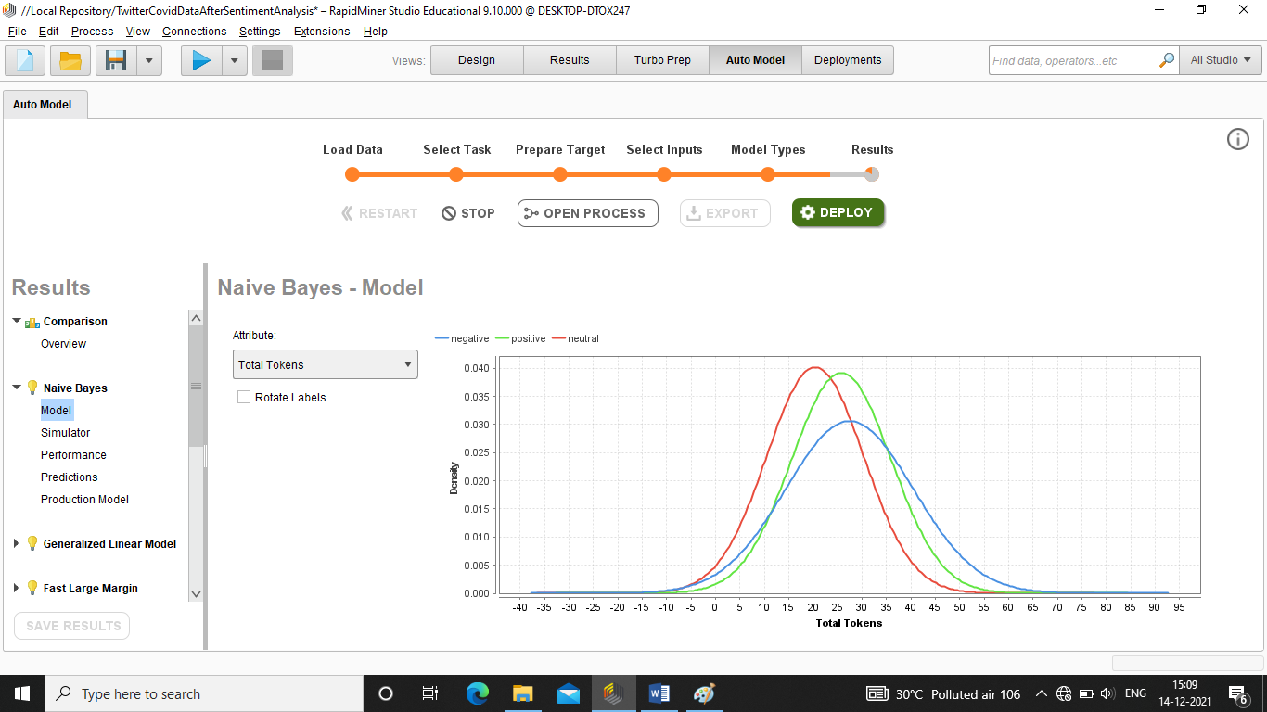

1. **Generated Output from Write Excel Operator**

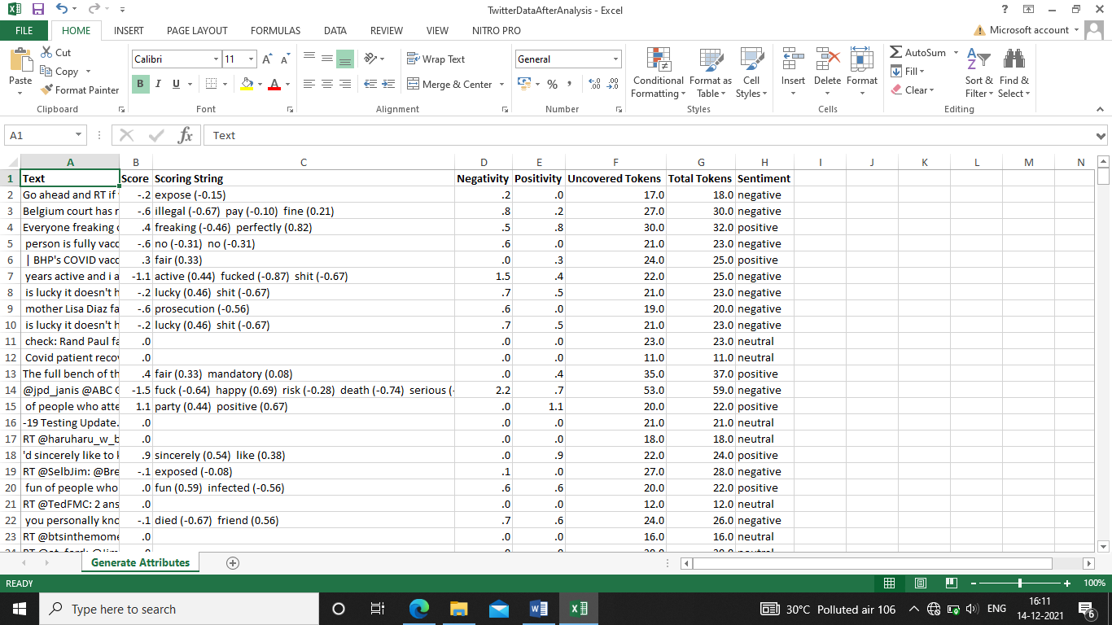

**Conclusion:**

As the concluding chapter has reached, it’s time to conclude all things we learn, we performed and the main our vision is achieved. The aim behind making the project has been achieved. During this whole journey we learn many new things as this whole journey has been very inspiring. We have been through the experience of handling ad manipulating the data and many more things. By this project we have understood and gone through many of the operations on the data like data analysis, data visualization, data reduction, discretization, prediction of class labels of given data instances, classifier models using different techniques, analyze the confusion matrix. The Sentiment Analysis has been a successful project. Hence, we conclude as thanking each and every person who has been involved in this journey without their contribution this success was not possible.